**Project Team 27**

Sprint #2

Week #1

Team Member Name – Swapnil Makarand Joshi

What I did since the last week scrum?

1. Created user stories
2. Discussed game aspects such as elements, scene, sound etc

What I plan to do next week?

1. Design UML Diagram
2. Start development of GUI element

What blockers I have?

None

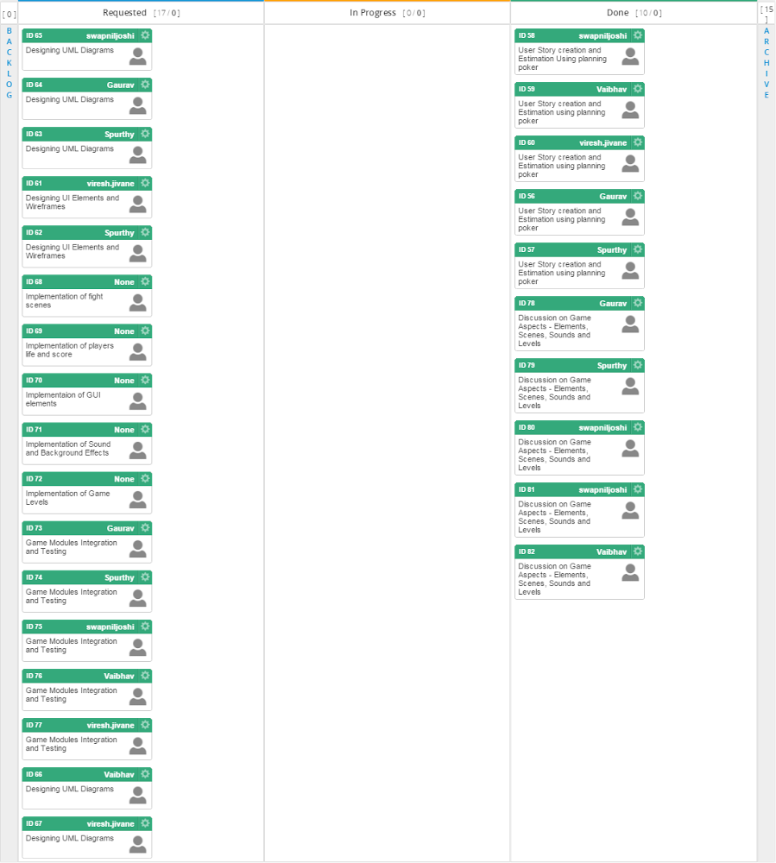

Task board in Kanbanize

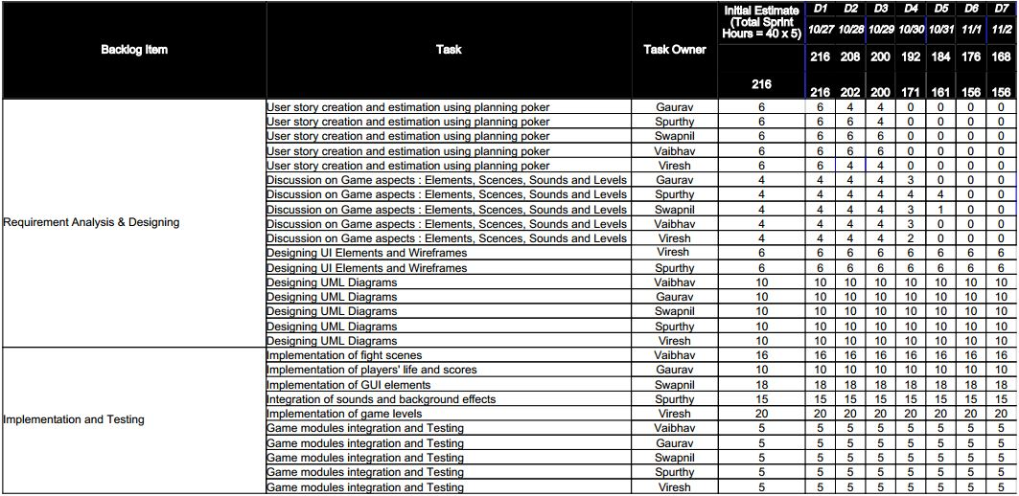

Weekly Standup Report

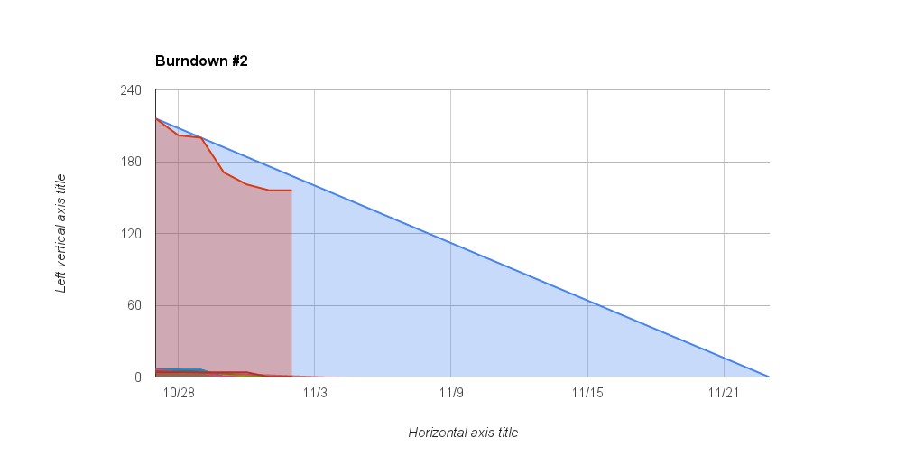

Burndown Chart